1. **Agenda**:
   1. $unset: Update Operator.
2. $unset:
   1. Used to remove a field from a document.
3. 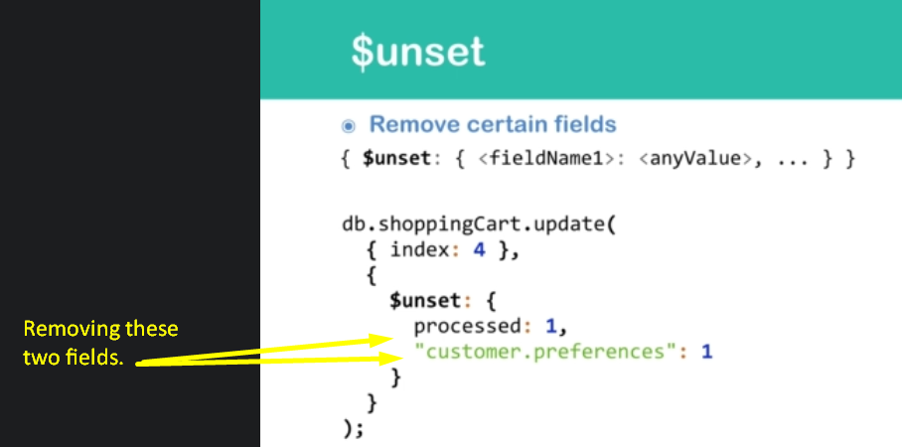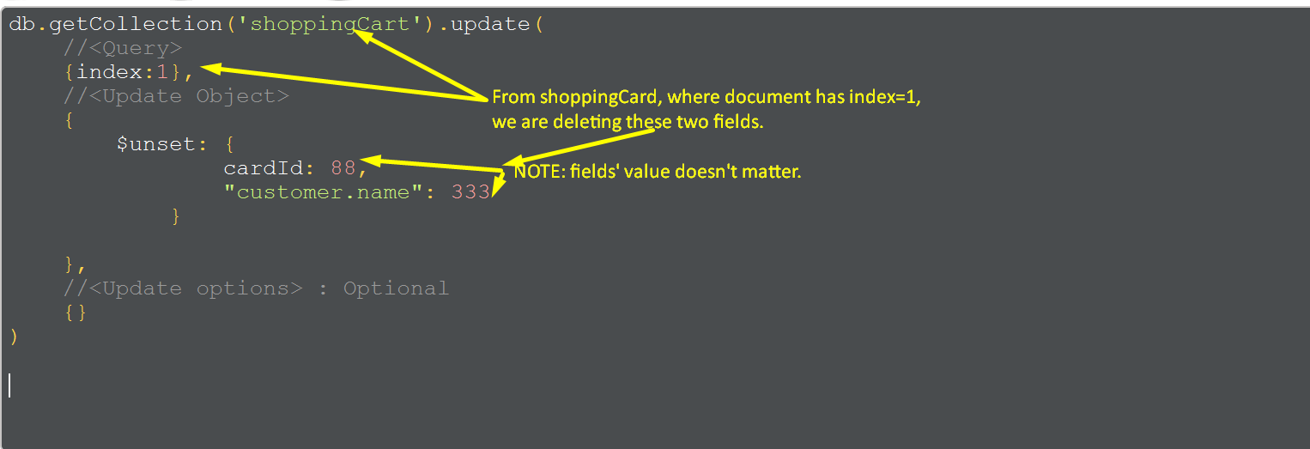
4. 